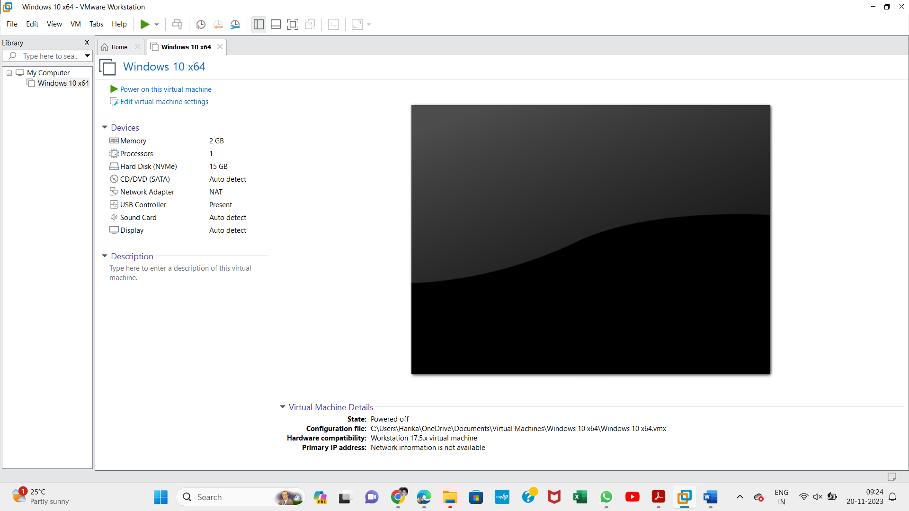

Experiment
–

14

Creation of a Virtual Hard Disk and Storage Allocation Using VMware Workstation

Aim

To create a virtual hard disk and allocate storage to a virtual machine using VMware
Workstation.

Procedure

1
. Open VMware Workstation on the Windows host operating system.

2
. Select the virtual machine and click Edit virtual machine settings.

3
. Click Add to add a new hardware device.

4
. Select Hard Disk from the device list and click Next.

. Choose the required virtual disk type, such as SCSI, and click Next.
5

6
. Select Create a new virtual disk and click Next.

7
. Enter the maximum disk size as 15 GB or the storage capacity specified in the experiment.

8
. Select Store virtual disk as a single file or Split virtual disk into multiple files.

9
. Click Next and specify the virtual disk filename and location if prompted.

10
. Click Finish to create the virtual hard disk.

11
. Verify that the newly created hard disk appears in the Virtual Machine Settings window.

12
. Power on the
virtual machine and verify that it operates correctly.

Output:

Result
Thus, a virtual hard disk was successfully created and storage was allocated to the virtual machine using VMware Workstation.

